Pet Plaque - Dearly

Engraving Order Form
(Proof Required)
Ship To: CLIENT DETAILS DATE:______________
Name:
Street Address:
City, State, Postcode:
Phone:
Email:
Please email completed form to: joanne@finaltouchaustralia.com.au

Once your form is submitted the process will take approximately 7-10 days until delivery. Payment is taken on the Still With Me Pet Urns website, please refer to website to make payment prior to submitting this form. Please note there is no choice in font or layout. Call our office on 07 3889 9607 with any further questions.

Item Selection - Pet Plaque

Paw Print Cut Out Plain

Text will be engraved exactly as entered, preserving all capitalisation and punctuation. Please print neatly.
Double check spelling!
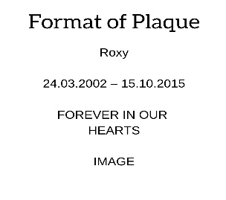
Line 1
Line 2
Line 3

Max 40 characters per line.

Artwork Choices: (OPTIONAL: to be included on PLAIN Pet Plaque)
Please circle if required. If not available similar will be provided.
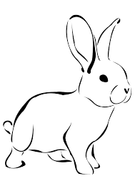
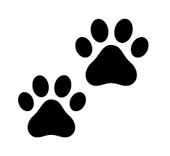
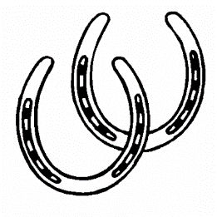
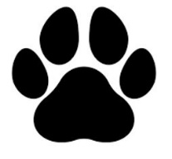
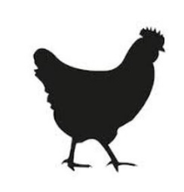


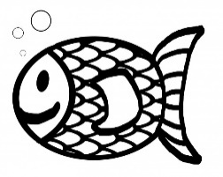 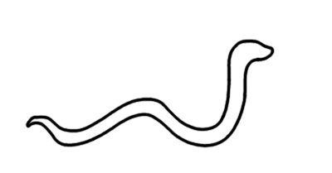 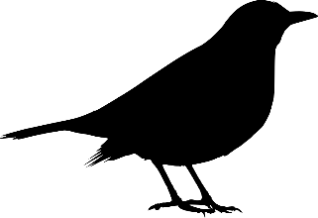 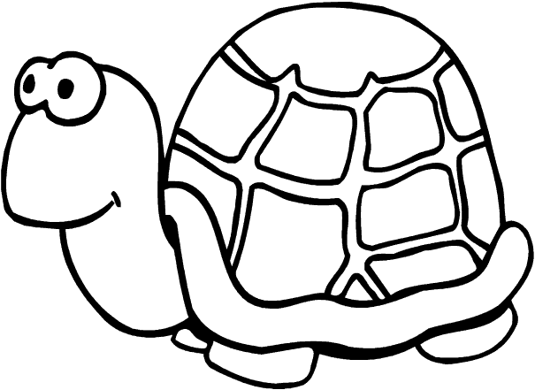 Enquire for more…

